SFO Food truck
This documents the captures the proposal for implementing a web API and UI between the user and the food truck lookup application. The scope of this doc is provide the high level solution to facilitate a discussion and identify problem areas.
Goals
- The food truck api is to allow users entering their location information either by entering an address or LAT/LONG
- The food truck API and subsequent Web UI will allow authenticated users to search a food truck in the San Francisco area by the following search criteria:
- All Food trucks in the SFO area
- Food trucks by their menu items
- Food trucks by their company name
- Food Trucks by their proximity to a specific location specified by the users source location with at least 5 trucks minimum as a result
- The Food truck API will have an upload feature that lets the administrator upload the latest repo from the San Francisco via secured API endpoint. In addition to the administration function via the Web UI. The API will expose several end points following a restful model.
Areas at consider are authentication and authorization for the administrators while users will only require users to authenticate but no authorization will needed. The end point will conduct the necessary security and validations of the user. Users that are not administrators can also use the web UI as an authenticated user or use the API endpoint directly. All status of the request made by the user will indicate an error or a successful request.
Basic User Experience:
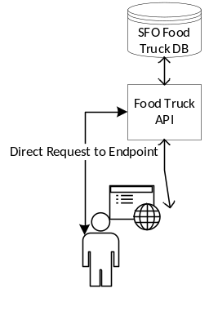
Metrics for success:
Number of registrations of users, Number of Queries done to the API
NPS (Net promoter scores from the website)
Feedback loop from users.
Reason to create this API
Fun way to tracking food trucks in the San Francisco area especially if you are hungry.

